BOOKS MANAGEMENT SYSTEM

SCOPE:

Tentative number of pages:

**1. /Home**---- it contains the catalogue or list of available books.

**Any user can view the catalogue of the book.**

Whenever the user clicks the issue button ----it will be checked weather he is logged-In or not.

If he is logged in …. He will be directed to:

**2. /Issue** (he will be directed to this page only when he is logged in)

Here the book he had selected to issue will be displayed automatically with his username, then the book will be issued.

Issue date –auto fill and return date ---can adjust manually.

**3. / Member Login**

This URL can be directly selected from the menu available. Or the user will be directed from /Home when he clicks ---issue button (and when he is not logged in).

**4. /forgot password**

When the member tries to login with wrong password.

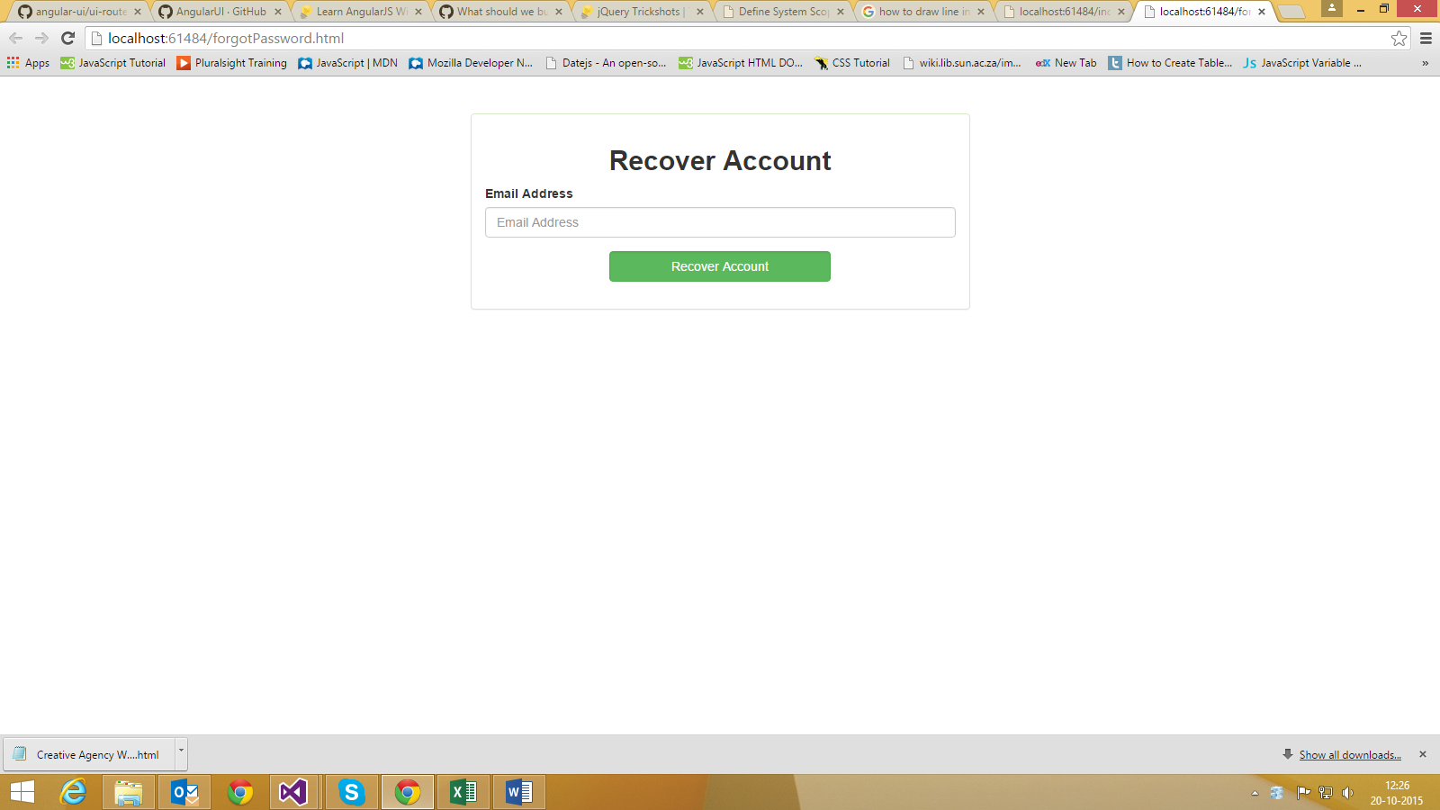

**5. / Member Register**

If user is not yet registered he will be directed to this page .Here he has to fill proper details to go ahead and resister himself!

Once he is registered he will be directed to /issue.

**6. / Search –** this URL is directly present in the menu 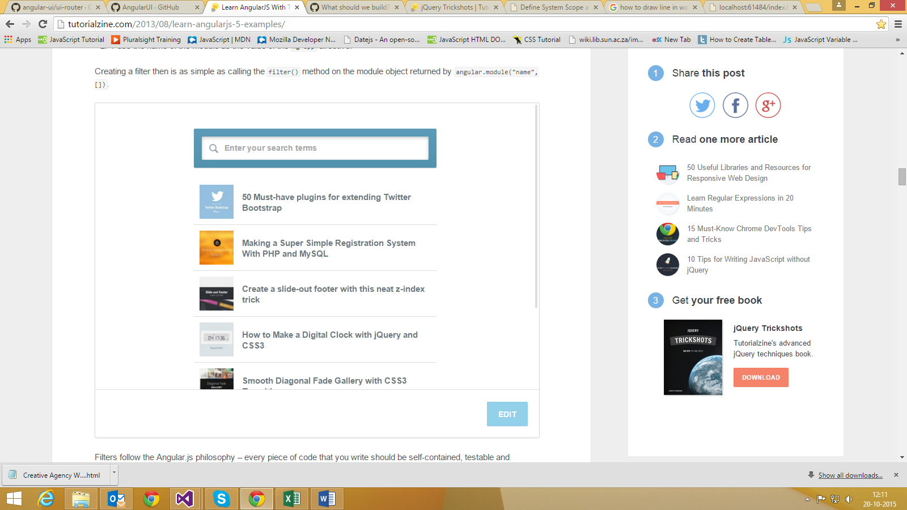

Any user can go for any URL’S present in the menu.

Except the /issue. ---- Only for the logged-in member.

Here for the development of the system tools used are:

1 .Angular JS

2. JQuery

3. Bootstrap

4. Css

5. JavaScript

And is developed in Microsoft visual studio -2013!

No database is used

Json object will be used to store the data temporarily.

Other JavaScript files will be:

App.js and other JavaScript files as when required will be created.